SIMATS ENGINEERING

SAVEETHA INSTITUTE OF MEDICAL AND TECHNICAL SCIENCES

CHENNAI-602105

CSA0839 – PYTHON PROGRAMMING FOR CYBER SECURITY

Submitted By :S. Jaswanth Venkata Rahul

1)

n = int(input("Enter the value of n: "))

for i in range(n, 0, -1):

for j in range(i):

print(chr(65 + j), end=' ')

print()

Output:

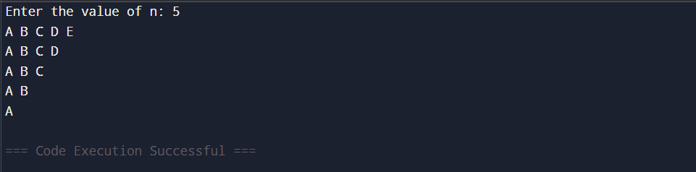

2)

def factorial(n):

fact = 1

for i in range(1, n+1):

fact *= i

return fact

x = float(input("Enter the value of x in radians: "))

terms = int(input("Enter the number of terms: "))

cos_x = 0

for i in range(terms):

sign = (-1) ** i

power = 2 * i

cos_x += sign * (x ** power) / factorial(power)

print("Cosine value using series =", cos_x)

Output:

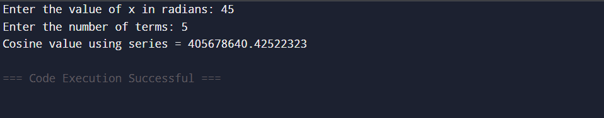

3)

def factorial(n):

fact = 1

for i in range(1, n+1):

fact *= i

return fact

n = int(input("Enter the value of n: "))

sum_series = 0

for i in range(n + 1):

sum_series += 1 / factorial(i)

print("Sum of the series is:", sum_series)

Output:

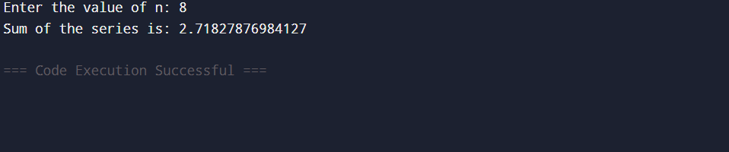

4)

num = int(input("Enter a number: "))

if str(num) == str(num)[::-1]:

print("The number is a palindrome.")

else:

print("The number is not a palindrome.")

Output:

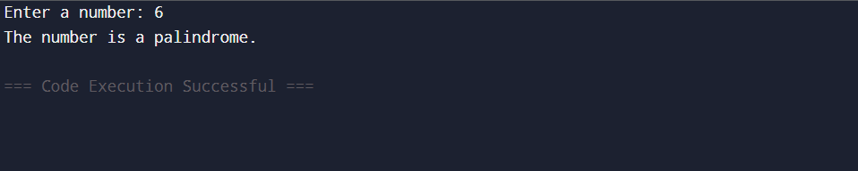

5)

def calculate_simple_interest(principal, years, is_senior):

if is_senior.lower() == 'y':

rate = 12

else:

rate = 10

interest = (principal * rate * years) / 100

return interest

principal = float(input("Enter the principal amount: "))

years = int(input("Enter the no of years: "))

is_senior = input("Is customer senior citizen (y/n): ")

interest = calculate_simple_interest(principal, years, is_senior)

print("Interest:", int(interest))

Output:

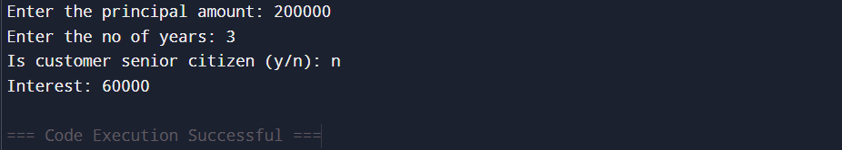

Test Case1:

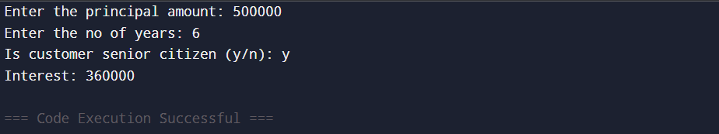

6)

def sumsquare(l):

odd = sum(x*x for x in l if x % 2 != 0)

even = sum(x*x for x in l if x % 2 == 0)

return [odd, even]

n = int(input("Enter the number of elements: "))

l = []

for _ in range(n):

ele = int(input("Enter the element: "))

l.append(ele)

result = sumsquare(l)

print(result)

Output:

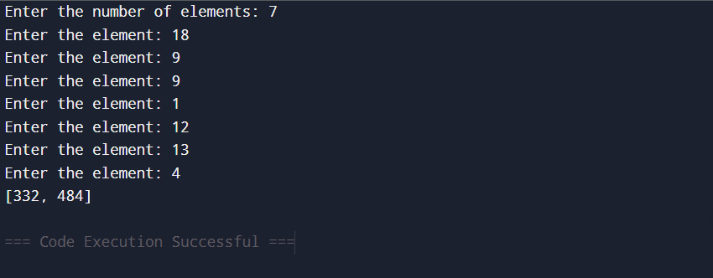

Test Case 1:

5,[1,2,3,4,5]

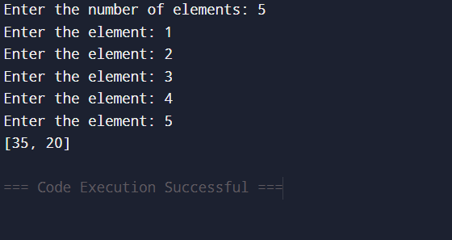

Test Case 2:

8, [2,4,5,6,7,11,12,13]

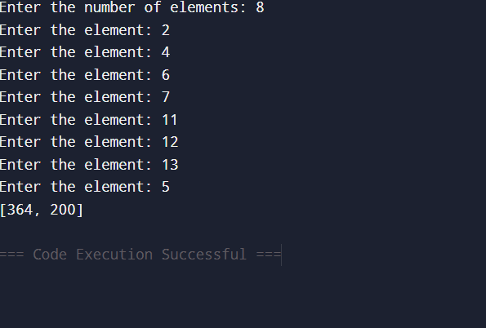

7)

i = 1

while True:

print(i)

if i == 5:

break

i += 1

Output:

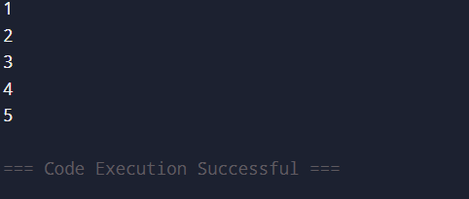

8)

for i in range(1, 11):

if i % 2 == 0:

continue # Skip even numbers

print(i)

Output:

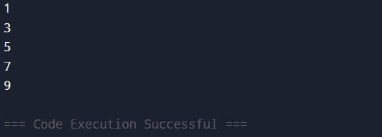

9)

num = int(input("Enter a number: "))

fact = 1

for i in range(1, num + 1):

fact *= i

print("Factorial of", num, "is:", fact)

Output:  
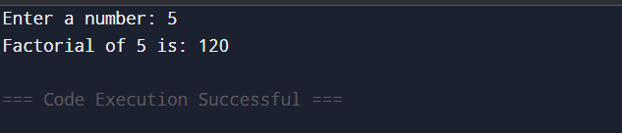

10)

n = int(input("Enter the value of N: "))

print("Prime numbers up to", n, "are:")

for num in range(2, n + 1):

is_prime = True

for i in range(2, int(num ** 0.5) + 1):

if num % i == 0:

is_prime = False

break

if is_prime:

print(num)

Output:

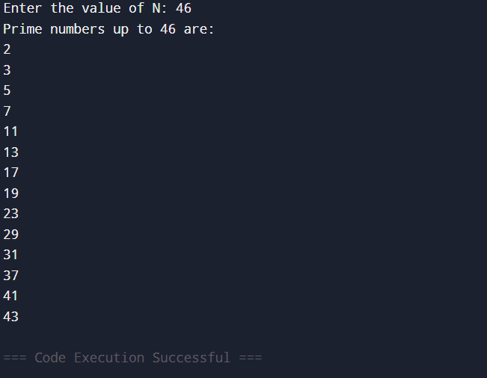

11)

rows = int(input("Enter the number of rows: "))

for i in range(1, rows + 1):

for j in range(i):

print("*", end=" ")

print()

Output :

